**Azure Data Factory Project: Implementing Retry Logic for Data Retrieval Failures**

1. Create Azure SQL Database (Source)

* Created a new SQL Database named RetryDemoDB
* Created a new SQL Server (retrydemosqlserverXYZ)
* Set admin login and password
* Added sample table Employees with 2 sample rows

CREATE TABLE Employees (

ID INT PRIMARY KEY,

Name VARCHAR(50),

Position VARCHAR(50)

);

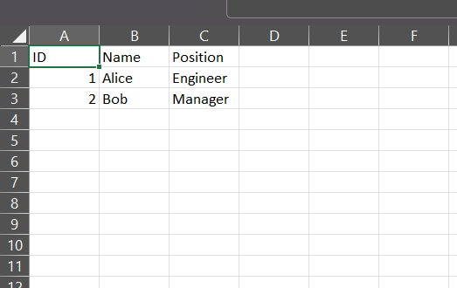INSERT INTO Employees VALUES (1, 'Alice', 'Engineer'), (2, 'Bob', 'Manager');

1. Create Azure Storage Account (Sink)

* Created a Storage Account named retrystorageXYZ
* Created a blob container named output-data

1. Create Linked Services in ADF

(a) SQL Database Linked Service:

* Type: Azure SQL Database
* Used SQL authentication
* Tested connection successfully

(b) Blob Storage Linked Service:

* Type: Azure Blob Storage
* Authentication: Account Key
* Tested connection successfully

1. Create Pipeline

* Created pipeline named RetryPipeline
* Added Copy Data activity named CopyEmployees
* Set:
  + Source dataset: SQL Dataset
  + 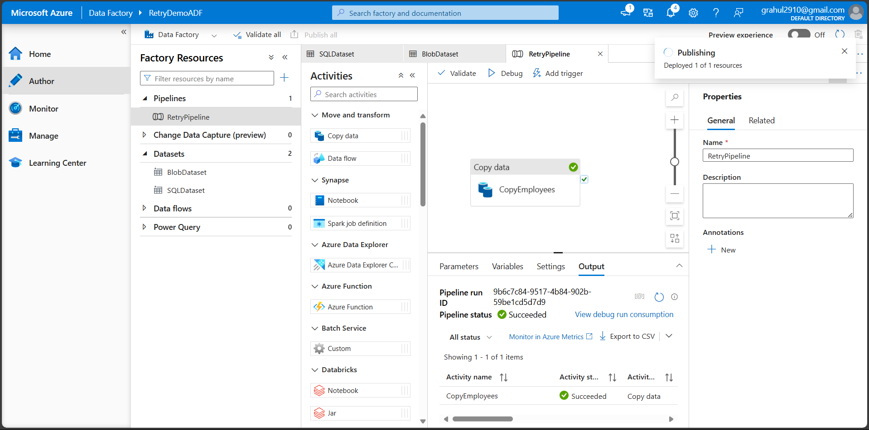Sink dataset: Blob Dataset

1. Configure Retry Logic (Fault Tolerance)

* Selected Copy Data activity → Right Properties Panel
* In Fault Tolerance section:
  + Retry count: 3
  + Retry interval: 10 seconds
* Enabled logging (optional) and selected Blob linked service

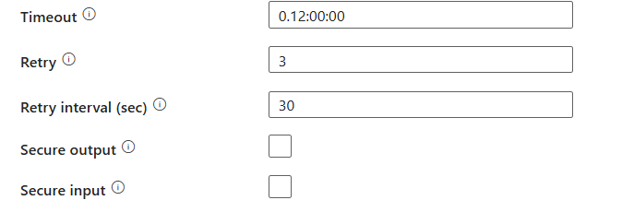

1. Debug and Publish

* Clicked Debug to run the pipeline and verify successful execution
* 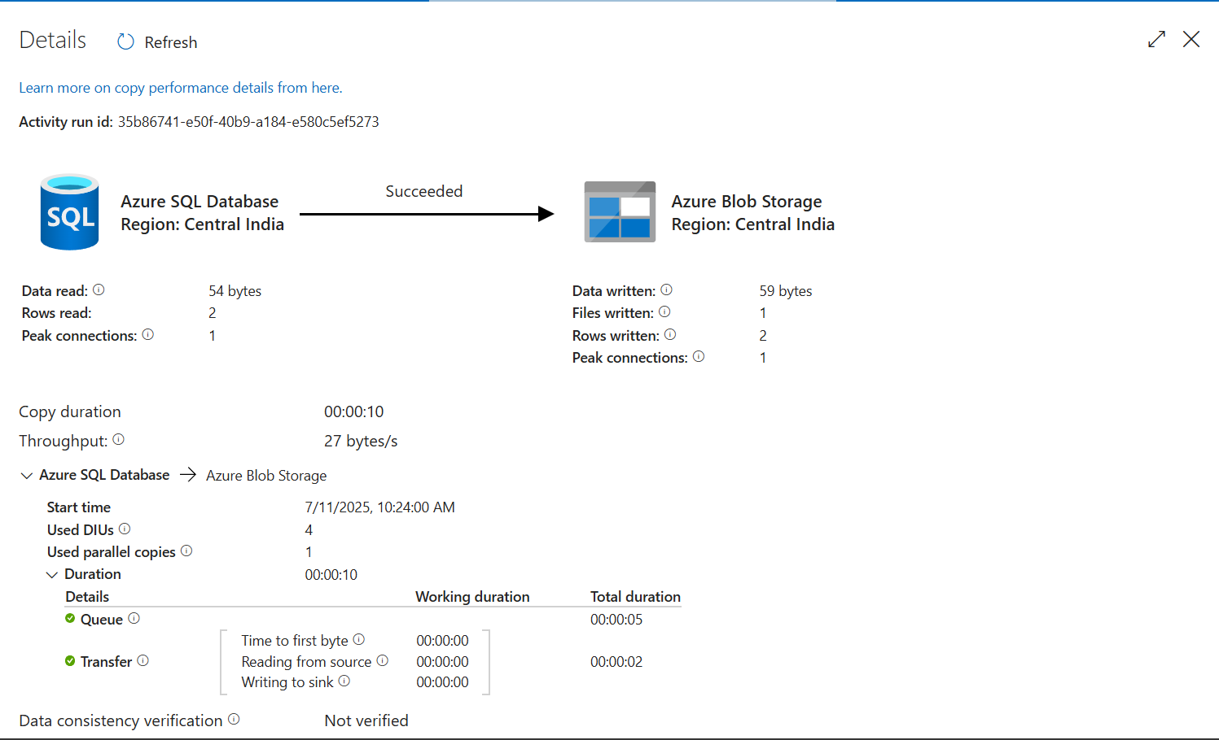Clicked Publish All to save all objects in the data factory

1. Verify Output

* Navigated to Azure Storage Account
* Change the password of the database to something that is not correct so that we can simulate the condition of a failure which will lead to the retry condition to occur
* Opened container output-data/output/
* 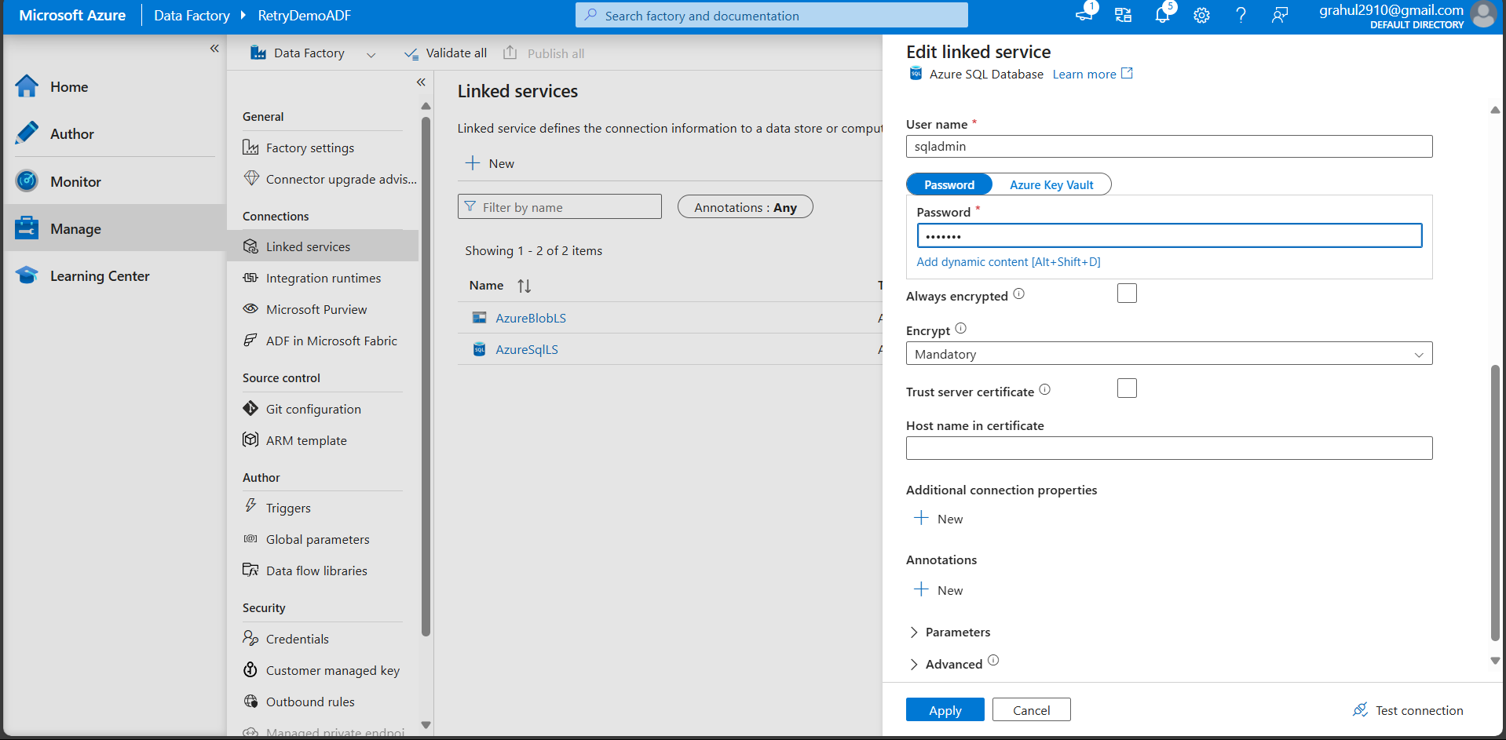Verified that employees.csv was generated with correct data’

